Need a Website or Blog?
We can build and host your website for as low as $10/mo!
Starting a Small Business?
Your website is your store front. Don’t pay an overpriced web design firm for a site that does not fit your business. Let us build it!
Does Your Organization Need a Website?
Whether your Organization is a School Club, Fraternity/Sorority, Non-Profit, or even a Gaming Clan, we have the tools you to need to share information!
Interested in Blogging?
We can set you up with your own custom blog that you have full control over. You just pay for hosting, no design needed!
Already Have a Website?
We offer standard hosting services that allow you to host your website for less money while increasing uptime and availability!

What Do I Get?
- Your own custom .com or .net  - Up to 50 Email Addresses  - Free Website Statistics | - Superb Customer Support  - Full Control Over the Content  - Prepaid Hosting for Convenience

Websites we have designed and currently host:
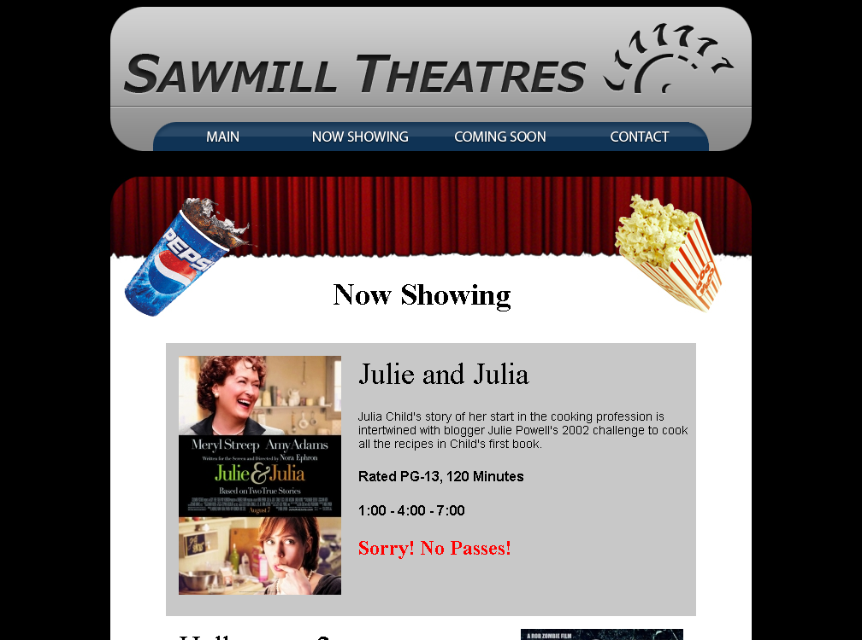 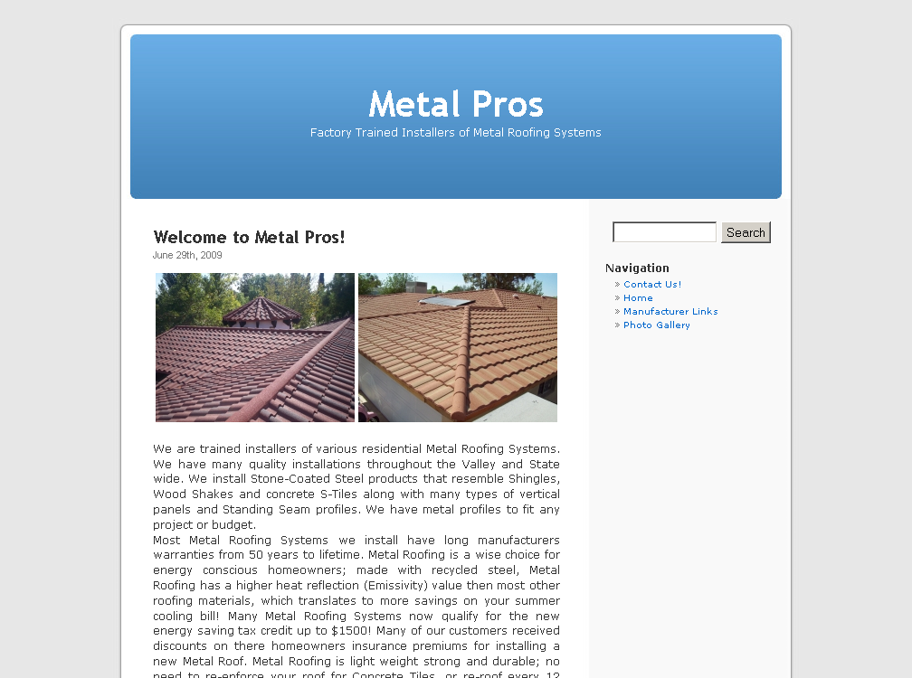 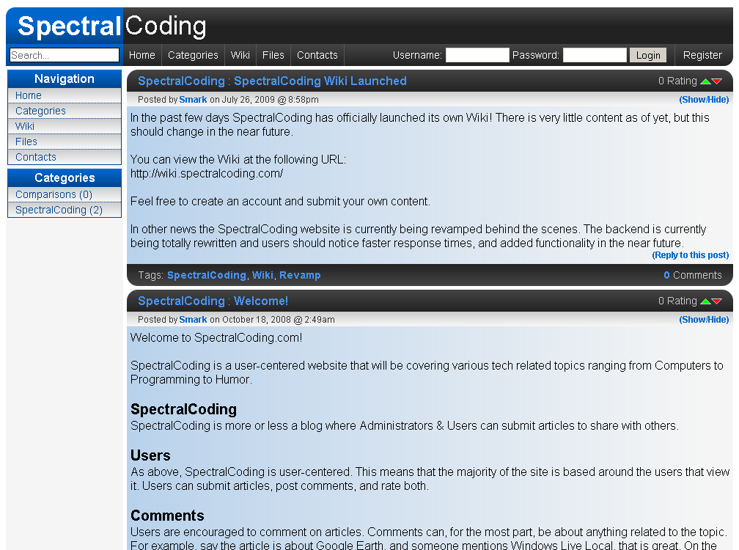
Movie Theatre Small Business Roofing Blog Tech Business/Blog

Rick Kabalan  (928) 978-5428  Business@SpectralCoding.com | Rick Kabalan  (928) 978-5428  Business@SpectralCoding.com | Rick Kabalan  (928) 978-5428  Business@SpectralCoding.com | Rick Kabalan  (928) 978-5428  Business@SpectralCoding.com | Rick Kabalan  (928) 978-5428  Business@SpectralCoding.com | Rick Kabalan  (928) 978-5428  Business@SpectralCoding.com | Rick Kabalan  (928) 978-5428  Business@SpectralCoding.com | Rick Kabalan  (928) 978-5428  Business@SpectralCoding.com | Rick Kabalan  (928) 978-5428  Business@SpectralCoding.com | Rick Kabalan  (928) 978-5428  Business@SpectralCoding.com | Rick Kabalan  (928) 978-5428  Business@SpectralCoding.com | Rick Kabalan  (928) 978-5428  Business@SpectralCoding.com | Rick Kabalan  (928) 978-5428  Business@SpectralCoding.com | Rick Kabalan  (928) 978-5428  Business@SpectralCoding.com | Rick Kabalan  (928) 978-5428  Business@SpectralCoding.com

Call or Email Rick Kabalan at (928) 978-5428 or Business@SpectralCoding.com

